Question # 1
Tick the correct option
1. | According to fundamental theorem of algebra, a polynomial of degree $n≥1$ has exactly_____roots
a. | n |  |  |  | b. |  | n+1 |  |  |  | c. | 1 | d. |  | Infinite
2. |  | If a constant m has to be zero of a polynomial p(x), what should be satisfied?
a. |  | P(x) > 1 |  |  | b. |  |  |  |  | P(x) = 1 | c. | P(x) < 1 | d. | None of these
3. |  |  |  | Each complex cube root of unity is ____ of other:
a. |  |  |  | Opposite | b. | Square |  |  |  |  | c. | Reciprocal | d. | Both b and c
4. |  |  |  | Evaluate $\frac{1}{w2}$:
a. |  |  |  | 1 | b. |  |  | 0 |  |  | c. | W | d. | Cannot be evaluated
`5. |  |  |  | What is true about fourth roots of unity
a. |  |  | Real root are additive inverses of each other |  | b. |  |  |  | Imaginary roots are conjugate of each other |  | c. | Both a and b | d. | None of them

Question # 2
Answer the following
1. | Find cube roots of : -125
2. | Find fourth roots of 81
3. | Evaluate : 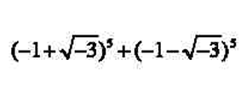
4.
5. | 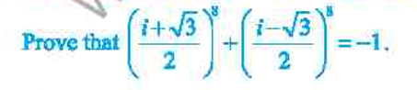
6. | 
7. | Factorize the following:  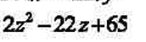  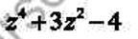
8. | Solve : 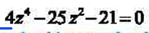
9.
10.

Question # 5
Long Questions
1. | Solve by using completing square :  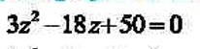
2.

